Canadian Women’s Heart Health Alliance
Training and Education Working Group | Member Profile

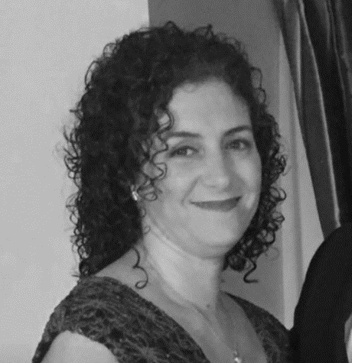 | Laura Avelar, RN  Woman with Lived Experience  NICU Nurse, The Ottawa Hospital  Ottawa , ON  Alliance member since 2021

Biography

My name is Laura Avelar. I would like to share my story to help women to become advocates for their heart health, to believe in their symptoms, and to voice their concerns by becoming more assertive with the symptoms they are feeling.

My heart health journey started approximately in 2007 at the age of thirty-eight. I can remember feeling my heart beating fast. This feeling was accompanied by shortness of breath and pressure in my left arm and chest area. I went to the emergency department where I was followed up for a heart attack. I was told I did not have a heart attack, but a left branch bundle block was noticed on my electrocardiogram. I was told not to worry, that this was just a finding. A few years passed and I progressively got more tired and symptomatic. After numerous appointments with my family physician and many cardiologists I was told the same thing. I was also told that I was depressed and was prescribed antidepressants. Despite the physician’s opinion, I did not start the antidepressants. In February of 2014, my symptoms progressed and worsened. I was sent to my fourth cardiologist to confirm that nothing was being missed.

In June 2014, my care was transferred to the Heart Function Clinic where I was diagnosed with Idiopathic Dilated Cardiomyopathy and Congestive Heart Failure. Besides the reality of my diagnosis, I remember feeling a sense of relief knowing that everything I had been feeling was real.

As women and as patients we should not feel isolated. Take initiative with whatever symptoms you may experience. Do not quit, or ignore your symptoms. I have realized that age and appearance sometimes can be deceiving, and even with normal values there still can be something truly wrong. It is important to keep an open communication with your health care team and remember that you know your body best. I want other women to look at my story and see not only a mother, wife, daughter, sister, nurse and friend, but a goal setter who doesn’t quit when things get rough. I want women to see that I did not let this disease control my life, but instead, I have learned how to control it. My disease does not define me. I am strong. I am a woman. I am a survivor. To all of the women out there: please remember that your heart health always comes first. We must also keep in mind that we are not Wonder Woman. Our goal should always be to live a symptom free, happy, and healthy life.

Thank you,
Laura

